Jalu Chaudhary

**Class IT-314-DL1**

**Practice Problems: PL/SQL Packages**

**Assignment 7-1: Creating a Package**

Follow the steps to create a package containing a procedure and a function pertaining to basket

information. (Note: The first time you compile the package body doesn’t give you practice with

compilation error messages.)

1. Start Notepad, and open the Assignment07-01.txt file in the Chapter07 folder.

2. Review the package code, and then copy it.

3. In SQL Developer, paste the copied code to build the package.

4. Review the compilation errors and identify the related coding error.

5. Edit the package to correct the error and compile the package.

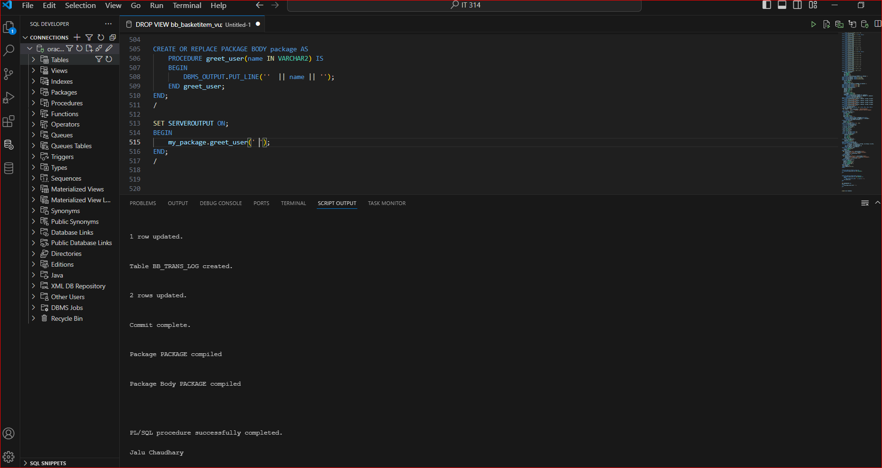

**Assignment 7-2: Using Program Units in a Package**

In this assignment, you use program units in a package created to store basket information. The

package contains a function that returns the recipient’s name and a procedure that retrieves the

shopper ID and order date for a basket.

1. In SQL Developer, create the ORDER_INFO_PKG package, using the

Assignment07-02.txt file in the Chapter07 folder. Review the code to become familiar

with the two program units in the package.

2. Create an anonymous block that calls both the packaged procedure and function with

basket ID 12 to test these program units. Use DBMS_OUTPUT statements to display values

returned from the program units to verify the data.

3. Also, test the packaged function by using it in a SELECT clause on the BB_BASKET table.

Use a WHERE clause to select only the basket 12 row.

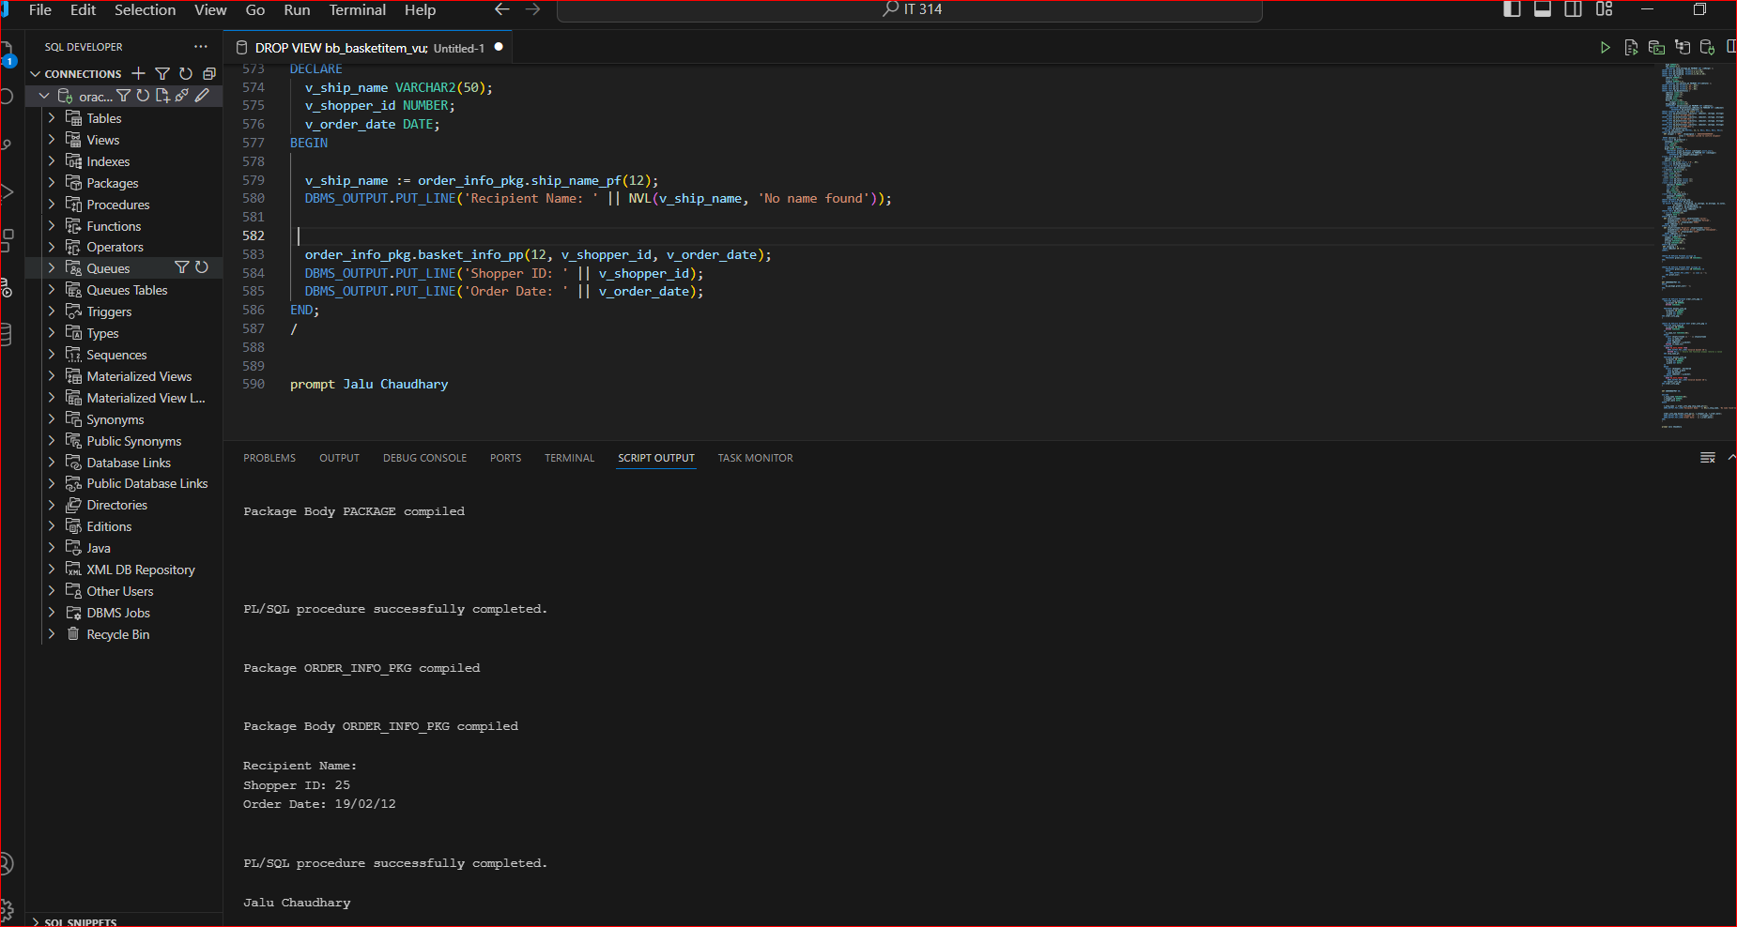

**Assignment 7-3: Creating a Package with Private Program Units**

In this assignment, you modify a package to make program units private. The Brewbean’s

programming group decided that the SHIP_NAME_PF function in the ORDER_INFO_PKG

package should be used only from inside the package. Follow these steps to make this

modification:

1. In Notepad, open the Assignment07-03.txt file in the Chapter07 folder, and review the

package code.

2. Modify the package code to add to the BASKET_INFO_PP procedure so that it also returns

the name an order is shipped by using the SHIP_NAME_PF function. Make the necessary

changes to make the SHIP_NAME_PF function private.

3. Create the package by using the modified code.

4. Create and run an anonymous block that calls the BASKET_INFO_PP procedure and

displays the shopper ID, order date, and shipped-to name to check the values returned.

Use DBMS_OUTPUT statements to display the values.

**Assignment 7-4: Using Packaged Variables**

In this assignment, you create a package that uses packaged variables to assist in the user

logon process. When a returning shopper logs on, the username and password entered need

to be verified against the database. In addition, two values need to be stored in packaged

variables for reference during the user session: the shopper ID and the first three digits of

the shopper’s zip code (used for regional advertisements displayed on the site).

1. Create a function that accepts a username and password as arguments and verifies these

values against the database for a match. If a match is found, return the value Y. Set the

value of the variable holding the return value to N. Include a NO_DATA_FOUND exception

handler to display a message that the logon values are invalid.

2. Use an anonymous block to test the procedure, using the username gma1 and the

password goofy.

3. Now place the function in a package, and add code to create and populate the packaged

variables specified earlier. Name the package LOGIN_PKG.

4. Use an anonymous block to test the packaged procedure, using the username gma1 and

the password goofy to verify that the procedure works correctly.

5. Use DBMS_OUTPUT statements in an anonymous block to display the values stored in the packaged variables.

**Assignment 7-5: Overloading Packaged Procedures**

In this assignment, you create packaged procedures to retrieve shopper information.

Brewbean’s is adding an application page where customer service agents can retrieve shopper

information by using shopper ID or last name. Create a package named SHOP_QUERY_PKG

containing overloaded procedures to perform these lookups. They should return the shopper’s

name, city, state, phone number, and e-mail address. Test the package twice. First, call the

procedure with shopper ID 23, and then call it with the last name Ratman. Both test values refer

to the same shopper, so they should return the same shopper information.

